
Wee Jasper Public School

WEEK 3 TERM 1 2010

Phone: Office(02) 6227 9652, Classroom: (02) 62279682 Fax: (02) 6227 9617
weejasper-p.school@det.nsw.edu.au

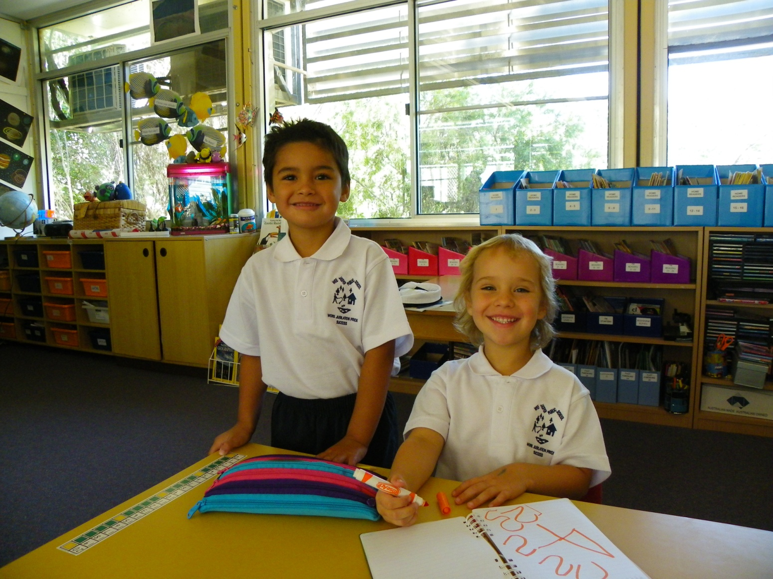

Jacob and Jess
First Day of Kindergarten

Coming Events

Swimming Lessons Thursday 11 Feb
School Open to Public 11am to 3pm Sat/Sun 13/14 Feb
Art Competition Wee Jasper Naturally Week End Sat/Sun 13/14 Feb
School Closed (Alternate Work Organisation) Monday 15 Feb
Best Start Assessments Kindergarten Students Tuesday 16 Feb
Swimming Lessons Wed 17 Feb
Swimming Lessons Thur 25 Feb
Swimming Lessons Fri 26 Feb
Communicating with your School Community Tuesday 2 March
Swimming Lessons Thur 4 March
Swimming Lessons Fri 5 March
School Closed (Alternate Work Organisation) Monday 15 March
Overnight Camp at Bongongo Public School Thur/Fri 8/19 March
Communicating with your School Community Monday 29 March
Good Friday holidays begin Friday 2 April
Term 2 Begins Tuesday 20 April
Wee Jasper Camp Tues/Wed/Thur
20/21/22 April
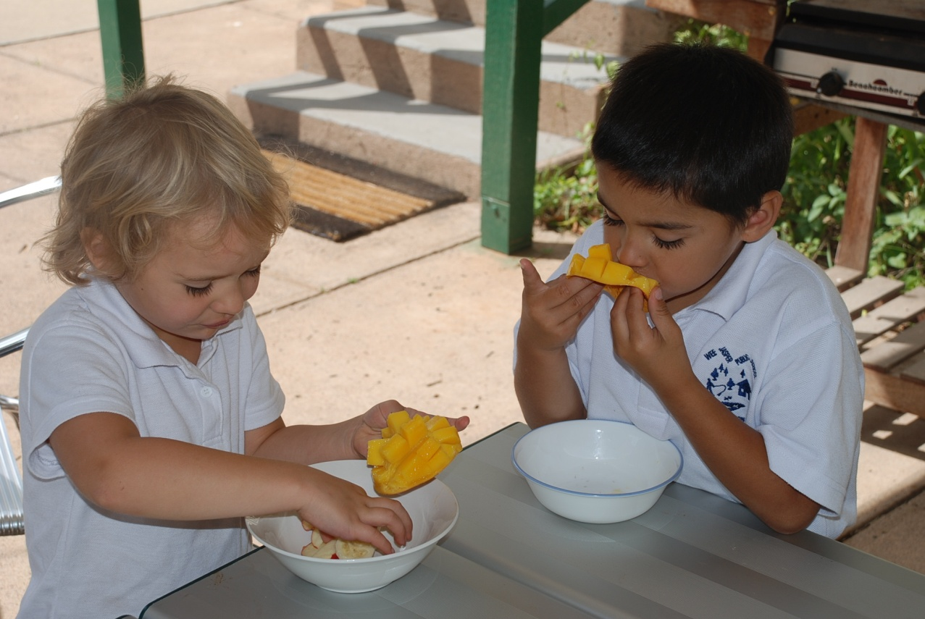Keeping the Energy Up – Fruit Break

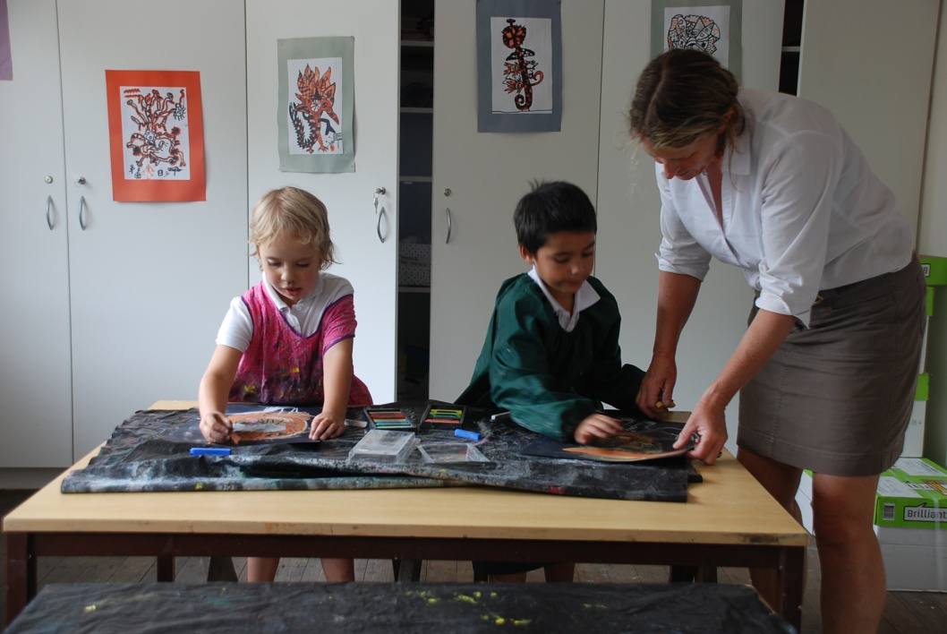
Welcome to 2010 and a year full of learning adventures for your children. Jess and Jacob had a most busy 2 weeks and Sally and I were surprised at their continuous energy levels throughout the day. Homework began in a big fashion with sight words to learn, mathematics dice games to be played and home readers to take home each night. The learning of letter sounds is taking place at full swing at school with a new letter sound learnt each day. Handwriting using correct pencil grip and a focus on accurate letter formation has been and will continue to be concentrated on during these formative stages. Many mathematics games have been played focussing on counting to 10 and building recognition of written numerals. 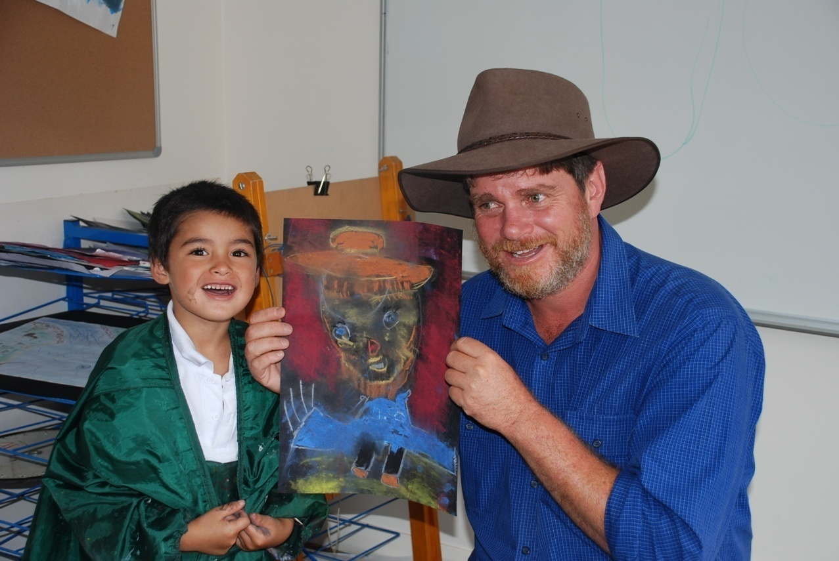Sally has had them writing accounts of their first swimming lessons and of the Cathle’s cat who has nominated himself as honorary life guard. Art lessons were taken very seriously with two amazing portraits done in oil pastels featuring myself. Can you see the grey hair?
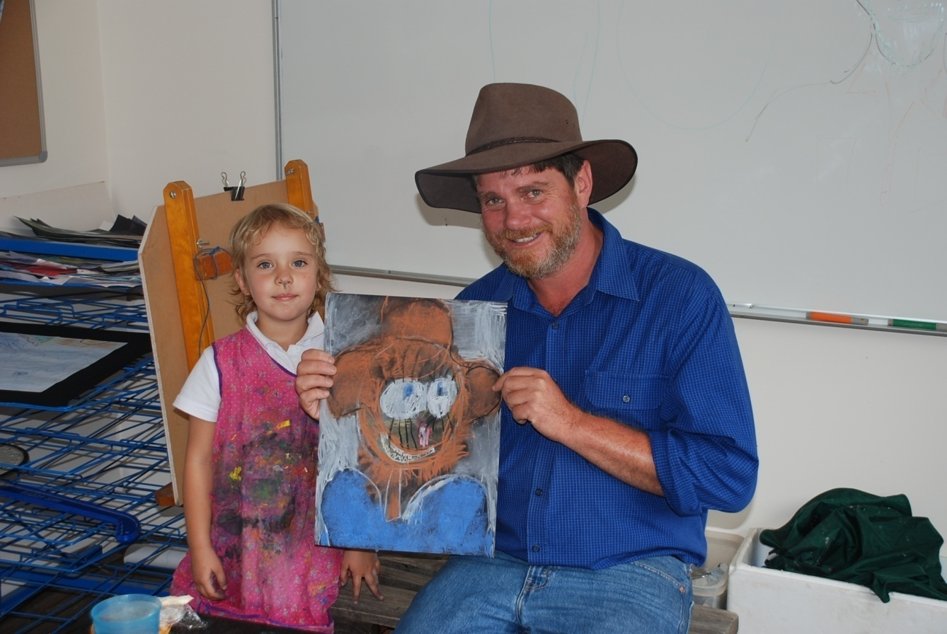
The eyes have it!

Swimming Lessons

We are most fortunate that Sally has made the effort to obtain and keep her swimming teaching accreditation over the years. The advances in the student’s confidence and skill levels in one lesson are amazing to watch. Sally and I will continue lessons this term until the water becomes too cold. Unfortunately, Sally needs to update her CPR certificate (swim teachers are required to do this once a year) this Friday, therefore there will be no lesson. Once again many thanks to Helen and Tim Cathles for use of their pool.

Best Start Assessments

Best Start Assessments will be run by a specialist in this area on Tuesday the 16 February. The assessment provides observations and records the knowledge, skills and understandings that our kindergarten children bring to school in the literacy and numeracy areas. This data will be used to further develop the teaching plan for each child. It is most important that your child be at school on this day. I will discuss results with parents at the first opportunity after testing.

Alternate Work Organisation

This term refers to a department approved work place agreement where the school day at Wee Jasper is longer than a standard school day. The result of the longer days allows the school to be shut 2 days per term, usually the Mondays of week 4 and week 8. This allows parents to book necessary appointments on these days, such as dental, doctor visits etc. and as a result helps to promote maximum possible attendance. The program recognises the difficulties that families in our relatively isolated situation have in getting to town during business hours after the school day has finished.

The school will be closed on:

Monday 15 February
Monday 15 March
Monday 17 May
Monday 7 June
Monday 9 August
Monday 6 September
Monday 1 November
Monday 29 November.

Communicating with your School Community–Department Run Course

This course has come at a timely moment when we need to promote our school to boost enrolments. It is aimed at training staff, parents and community members in ways to effectively promote the school through newsletters, the internet and printed material. Sally and I will attend. Interested parents and community members who wish to attend the 2 day course, which is run in Yass on the 2 and 29 March , please contact me.

Overnight Camp at Bongongo

This camp will be a culmination of studies around fishing which Sally has been undertaking with the students. The kids will chance their hand at catching a fish in Adjungbilly Creek and also undertake the Stream Watch Survey, which determines water quality through the variety of aquatic insect life which they catch in nets. More information about this camp in the next newsletter and Sally's fishing program.

School Open Next Weekend 13/14 February

There will be an influx of visitors in town to attend the host of events during the Wee Jasper Naturally Weekend. The school will be open to inspection by the public. If you know of a family who might be interested in exploring a country education for their children please invite them to drop in, meet Sally and I and explore what the school has to offer.

Art Competition
Don’t forget to visit the art displays in the Memorial Hall during the weekend to see your child’s art work on public exhibition!

The Wee Jasper Sea to Summit Adventure Camp

This one promises to be the best one yet! Seventy students from 6 small country schools : Cabramurra; Bongongo; Reids Flat; Rugby; Rye Park; Wee Jasper School and 10 students on a cultural exchange from Franklin School in Wollongong. Students will descend on Helen and Ian Cathle’s Cooradigbee Shearers Quarters for three days starting 20 April. The camp allows students to mix in groups of their own age group which many students within our small school network unfortunately do not have the opportunity to do on a regular basis. Students also experience different teachers and their styles which all help to ensure a successful transition to high school. Planning for camp is well under way with the following presenters secured:

Andrea Holer - ‘Circus Skills.’ Tremendous fun while developing gross motor skills, hand eye co-ordination, throwing ,catching and many other skills while using circus equipment and performing circus tricks. Andrea will also be presenting puppet shows based on local environmental themes.

Arthur Conlon -Aboriginal Artist. Arthur is a most entertaining presenter enjoyed by students and adults alike. Arthur will be telling many stories around aboriginal culture and students will be taking home a beautiful piece of art work. His classes encourage students to set and reach achievable goals and to fully participate at school.

Mark Austin –Author. We first met Mark last year at Bongongo School where he presented his children’s book, “ Ringle Tingle Tiger.”He is highly entertaining, fostering a keen interest in reading and also provides an insight for older students in the planning process of producing stories and art work for publication. Mark will run a range of activities fostering within children a love of reading and writing.

Bernadette Ramsay- Professional Tennis Coach. Our favourite coach will also be busy teaching tennis skills to the students.

We will also have a trained PE teacher on site to run fun games if groups finish at various times.

Other activities will include: “The Monster Ball Challenge,” groups of students pushing a large soccer ball to the top of the large hill near the shearer’s quarters; singing around the camp fire; damper cooking; toasting marshmallows; sketching post cards and to end the camp a fishing trip to Barbers Bay.

Junior students will sleep in the shearers’ accommodation while older students will be in tents. Kim Gurnaní is organising the catering for the camp and the menu looks delicious. Students will be spoilt and camp food in the future will seem pretty ordinary!

P&C News

My thanks to all people who attended the P&C AGM last week. Congratulations to the following people for their election to the committee:
President Michael Carey
Vice President Carol Webeck
Secretary Kate Howarth
Treasurer Irene Holloway

$1850 was allocated for immediate spending which included:
$ 150 – scrapbooking – creating a year long record of each student’s days at school.
$1000- reading scheme/Big Books
$ 400 - art supplies
$ 300 - BBQ.
The P&C efforts and donations are most appreciated. Thank you.

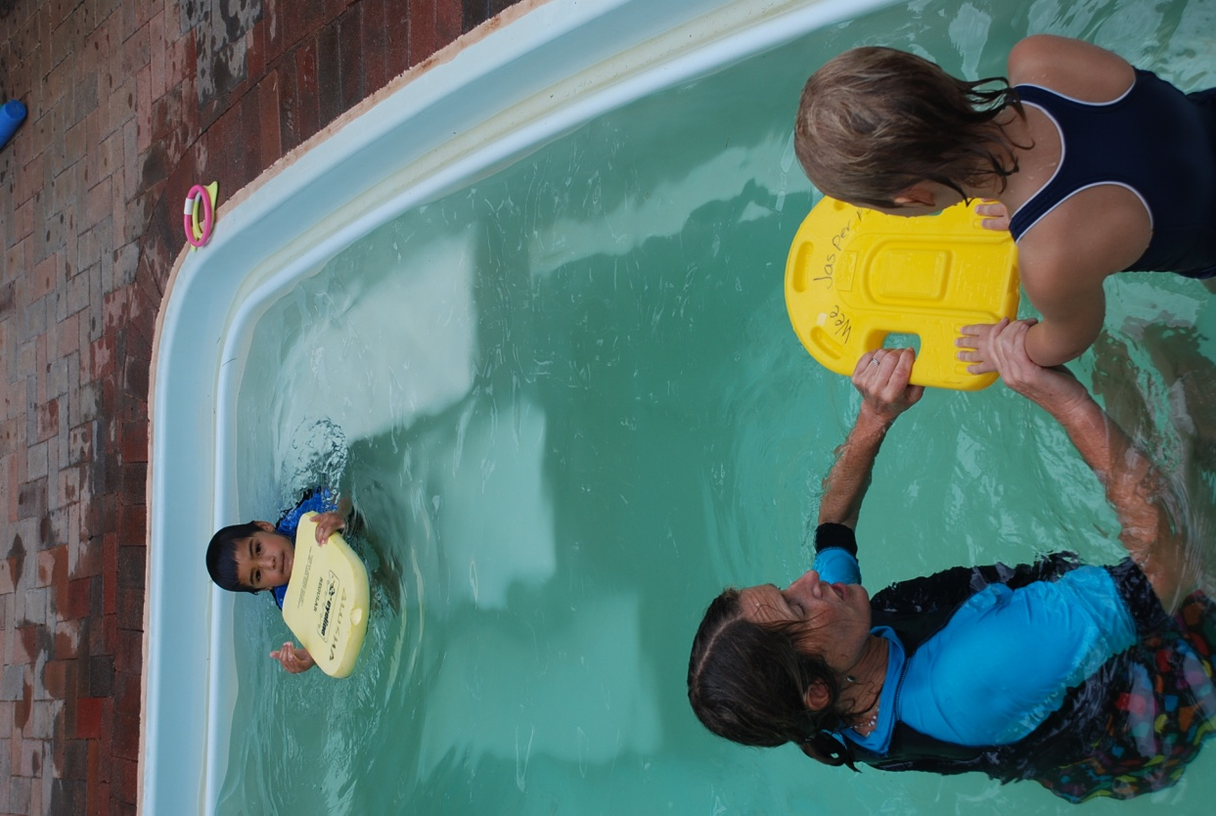

“Arms straight, push with your legs, look at the bottom of the pool and kick with straight legs.” No worries!

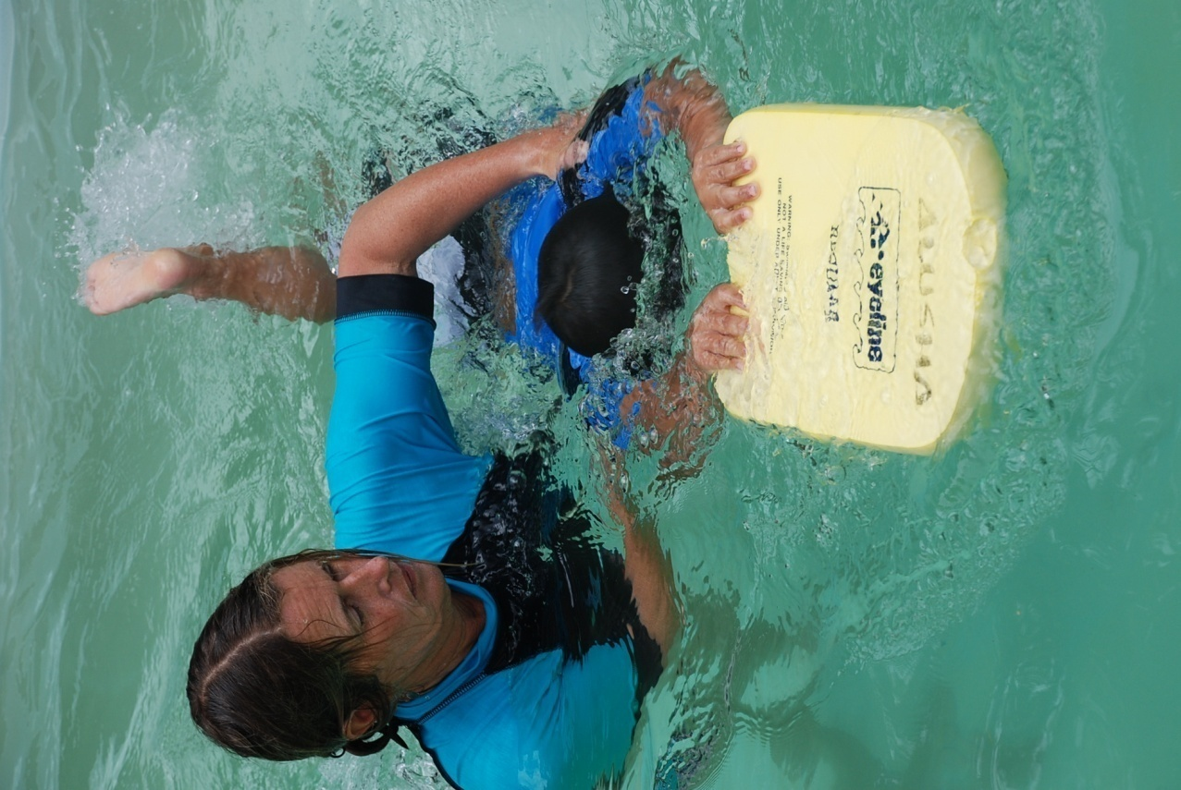

Good One!

Bunnings BBQ P&C Fundraiser

This is one of the P&C’s big fundraisers of the year. All the ground work is organised. We could really do with your help on the day. If you could assist with cooking sausages or serving either on Saturday morning or in the afternoon please let me know.
Where: Bunnings car park Belconnen.
When: 9am to 4pm Saturday 20 February.
Please contact me if you can help.

Warm Thank you

Last weekend was invited to attend the Wee Jasper Community Association Meeting. There was a tremendous turn out and great concern for the future of the school. May I thank all there for their support and input in to the meeting. I will keep all parties informed of the future progress of marketing our school.

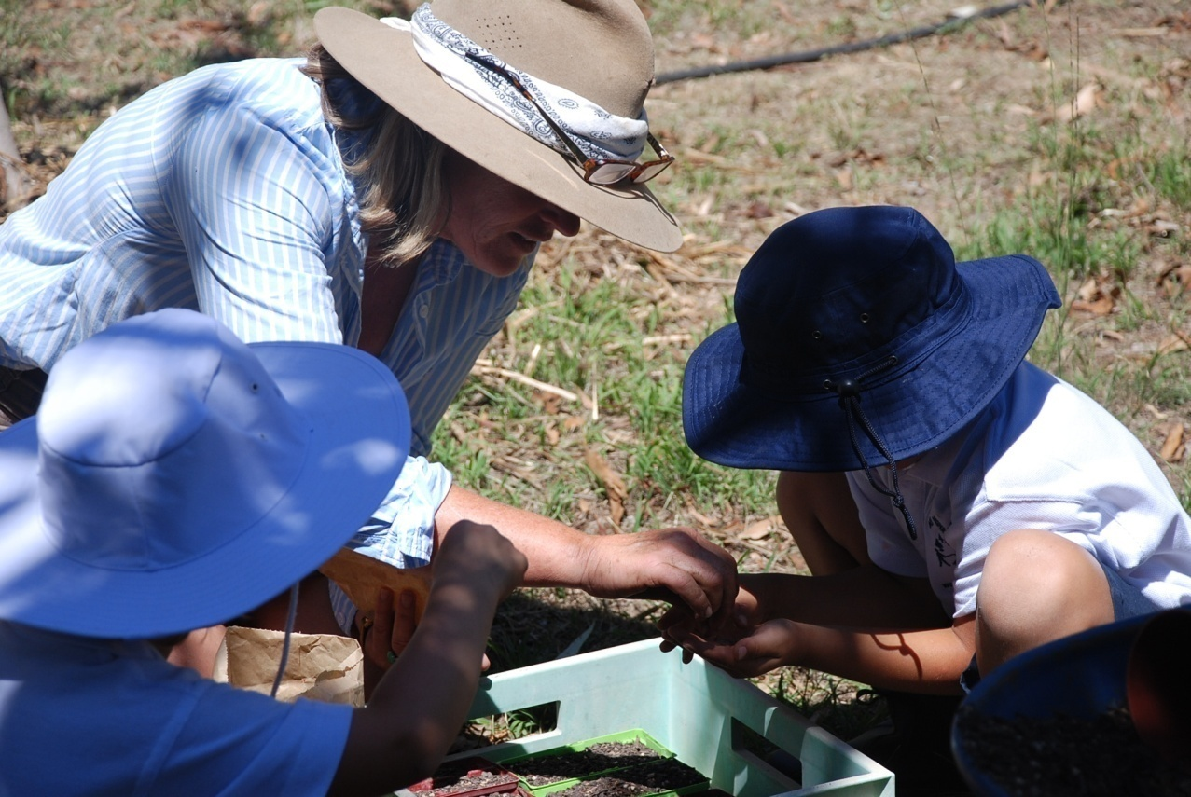

Sally and the kids planting yellow box seeds for propagating.
The seedlings will be planted in Wee Jasper.

Voluntary contributions

The voluntary contributions for excursions and texts books for 2010 is:

Excursions $100 per child

Text books $20 per child

These contributions can be paid over the next two terms on a payment plan if required.

The school has a comprehensive excursion/camp programme and we appreciate the contributions that go towards keeping this programme operating.

School Hours

School commences 9.05am and finishes 3.15pm

Staff will be available to supervise children from 8.45am onwards.

School Absences

If your child is absent from school please notify the school by phone or email that your child will be absent and the reason.

A signed note explaining the absence must also be given to the school on the student’s return.

Thanks – Mark

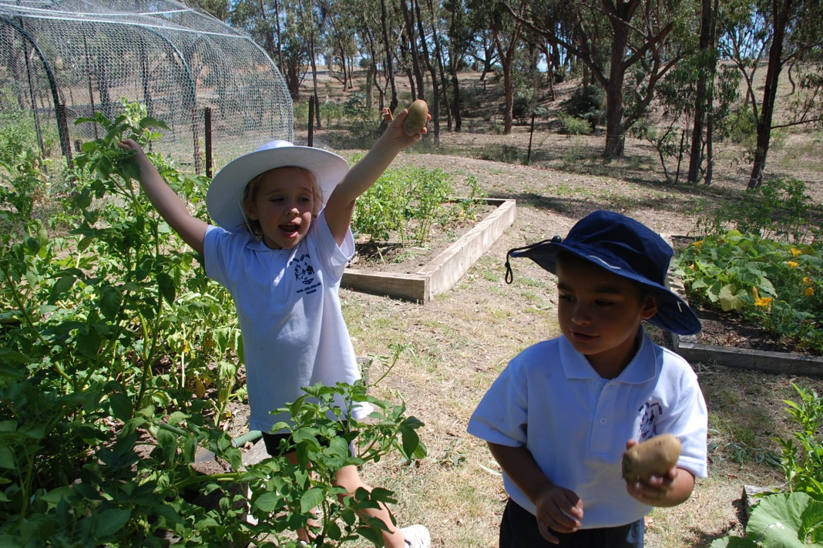
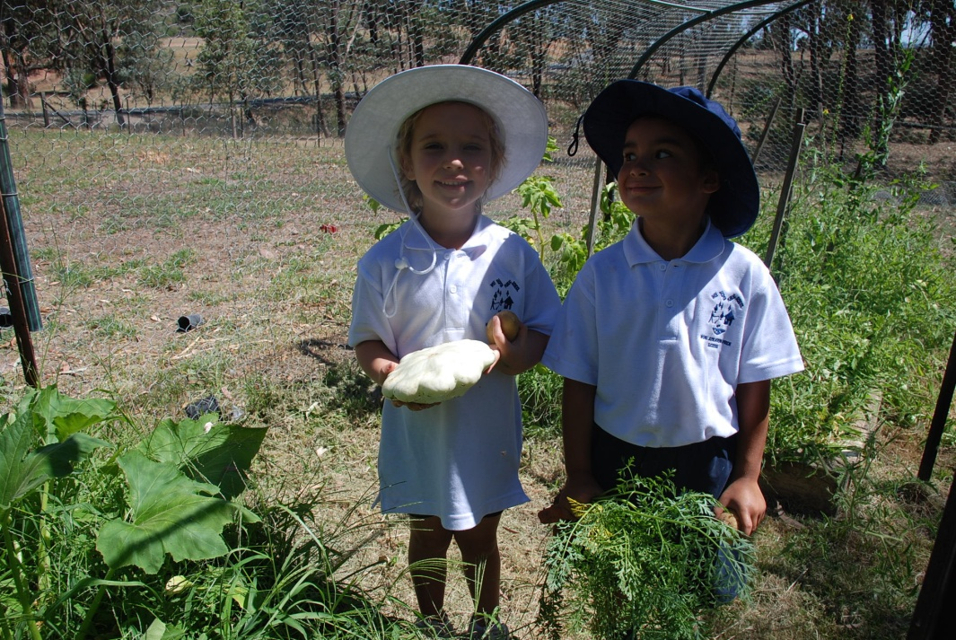

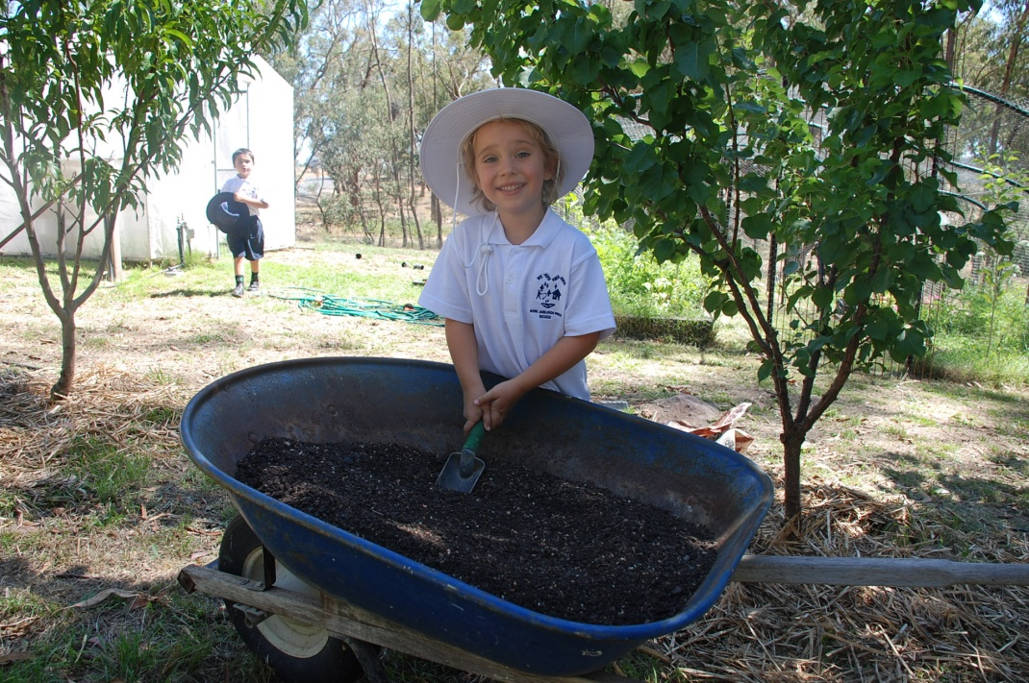

Fun in the vege patch.

