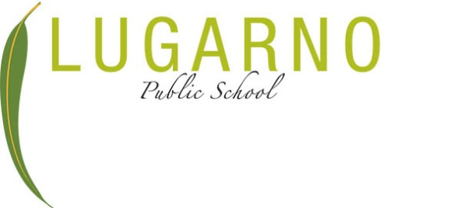
Old Forest Road
Lugarno NSW 2210
T 02 9153 9843 F 9534 1337
E lugarno-p.school@det.nsw.edu.au
www.lugarno-p.schools.nsw.gov.au

Dear Parent/Guardian,
External Provider – Permission to work with student at Lugarno Public School
At your request, Lugarno Public School agrees to allow ____________________________ (external provider) to provide ____________________ (service type) for your child at the School.
We seek your consent to share information about your child with the external provider. We require this permission to enable the service to be provided in the school. Can you please sign this form to acknowledge that you agree to the sharing of this information.
Permission Form
I acknowledge and understand that:
- The School may collect information from the Contractor;
- The School may also share information with the Contractor;
- This information (a and b) may include personal and health details about my child, such as the nature and implications of their medical condition;
- The purpose of sharing this information is to assist the School in arranging and providing appropriate support for my child during school hours and school-related activities;
- The School Principal may discuss this information with relevant Department staff to ensure appropriate care for my child;
- The School will not share this information with any third parties except as required by law or in accordance with legal obligations;
- As a parent/carer, I can request access to the information provided by the Contractor through the School;
- The School will manage and store this information in line with the Department’s guidelines and legal obligations for information handling.
Student’s Name: ___________________________
Parent/Guardian’s Name: ___________________________
Parent/Guardian’s Signature: ___________________________
Date: _______________________________________

