NSW Department of Education 

Coopernook Public School Behaviour Support and Management Plan

Overview
Coopernook Public School is committed to explicitly teaching and supporting student’s social and emotional development. We recognise that all behaviour is purposeful and a form of communication. It is our role to support students, through care and genuine concern to help them understand what needs they are attempting to satisfy and teach them how this can be done in a responsible manner.
Our goal is to inspire every child to participate positively in the school community and beyond. We focus on promoting excellence, opportunity and success for every student, every day. We value and strive to develop safe, respectful learners in a caring learning community.
Principles of positive behaviour support, trauma-informed practice, inclusive practice, and social emotional learning underpin our daily practice. High expectations for student behaviour are established and maintained through effective role modelling, explicit teaching, and planned responses.
To achieve our mission, key programs prioritised and valued by the school community are:
- Brain Gym
- Early Intervention
- Social Emotional Learning

These programs prioritise social and emotional learning which supports good mental health, positive relationships and supports prevention of bullying, leading towards students who have the competency to be self-managed.
Coopernook Public School rejects all forms of bullying behaviours, including online (or cyber) bullying by maintaining a commitment to providing a safe, inclusive, and respectful learning community that promotes student wellbeing. Staff are committed to establishing evidence-based approaches and strategies that promote a positive climate where bullying is less likely to occur.
All members of the school community are active participants in building a welcoming school culture that values diversity and fosters positive relationships. A key component of a supportive school culture is building respectful relationships and an ethos that bullying is not accepted, in both online and offline environments. School staff actively respond to student bullying behaviour.

Partnership with parents and carers
Coopernook Public School will partner with parents/carers in establishing expectations for engagement in developing and implementing student behaviour management and antibullying strategies, by:
- inviting parent/carer and student feedback through formal and informal means, such as NSW Public Schools Surveys, school surveys, consulting with the P & C and local AECG
- using concerns raised through complaints procedures to review school systems, data and practices.
Coopernook Public School will communicate these expectations to parents/carers through the school newsletter and school website. Our school proactively builds collaborative relationships with families and communities to create a shared understanding of how to support student learning, safety and wellbeing.

School-wide expectations and rules
Coopernook Public School has the following school-wide expectations and rules:
To be safe, connected and engaged learners.
Safe | Connect | Engage
Be kind and value others | Be ready to learn | Be your best
Work co-operatively | Accept differences | Overcome challenges
Use appropriate language | Be reflective | Ask for help
Be respectful | Be encouraging | Restore harm

Behaviour code for students
NSW public schools are committed to providing safe, supportive and responsive learning environments for everyone. We teach and model the behaviours we value in our students.
The Behaviour Code for Students can be found at https://education.nsw.gov.au/policy-library/policyprocedures/pd-2006-0316/pd-2006-0316-01. This document translated into multiple languages is available here: Behaviour Code for Students.

Whole school approach across the care continuum
Our school embeds student wellbeing and positive behaviour approaches and strategies in practices across the care continuum to promote positive behaviour and respond to behaviours of concern, including bullying and cyber-bullying behaviour.
These approaches and strategies are built on a foundation of evidence-based effective classroom practices that set the tone for engagement with learning and respectful relationships. These practices include:
- stating and explicitly teaching classroom expectations
- establishing predictable routines and procedures that are communicated clearly to students
- encouraging expected behaviour with positive feedback and reinforcement
- discouraging inappropriate behaviour
- providing active supervision of students
- maximising opportunities for active engagement with learning
- providing carefully sequenced engaging lessons that provide options for student choice
- differentiating learning content and tasks to meet the needs of all learners.
Care Continuum | Strategy or Program | Details | Audience
Prevention | Social-emotional learning | The social-emotional learning is an evidence-based comprehensive mental health and wellbeing approach based on a combination of social and emotional learning, preventative mental health, resilience and life skills. | All
Prevention | Brain Gym | Brain Gym Program utilises 26 specifically designed movements and related techniques to assist with self-regulation. | All
Prevention | Child protection | Teaching child protection education is a mandatory part of the syllabus. | Students K - 6
Prevention / Early Intervention / Targeted / Individual | Australian eSafety Commissioner Toolkit for Schools to prevent and respond to cyberbullying | The toolkit resources are categorised into four elements: Prepare, Engage, Educate and Respond. The resources are used to engage with the school community about creating and maintaining safe online environments to prevent cyberbullying incidents. The toolkit includes actions to report and manage cyberbullying incidents. | All
Early Intervention | Stormbirds | Small group intervention to support and increase the coping strategies of students who have been impacted by a natural disaster or trauma | Individual students K - 6
Targeted / Individual intervention | Learning and Support | The LST works with teachers, students and families to support students who require personalised learning and support. | All
Targeted / individual intervention | Attendance support | The LST refer students to the attendance co-ordinator who will convene a planning meeting with students, families and teachers to address barriers to improved attendance and set growth goals. | Individual students, attendance co-ordinator
Individual intervention | Individual behaviour support planning | This may include developing, implementing, monitoring and reviewing: behaviour support, behaviour response and risk management plans. | Individual students, parent/carer, LAST

Planned responses to positive appropriate behaviour, inappropriate behaviour and behaviours of concern, including bullying and cyber-bullying

Identifying behaviour of concern, including bullying and cyberbullying
A behaviour of concern is challenging, complex or unsafe behaviour that requires more persistent and intensive interventions. A behaviour of concern does not include low-level inappropriate or developmentally appropriate behaviour. Bullying behaviour involves the intentional misuse of power in a relationship, is ongoing and repeated and involves behaviour that can cause harm. See Appendix 1.

Coopernook Public School staff will staff will identify inappropriate behaviour and behaviours of concern, including bullying and cyber-bullying through a range of channels, for example:

directly observing a student’s behaviours, interactions, verbal communications, or work produced (such as written materials, performances or artworks)

a person disclosing information that is not previously known, either because it is new information or because it has been kept a secret

concerns raised by a parent, community member or agency.
Students or parents can report bullying to any staff member. NSW public school principals have the authority to take disciplinary action to address student behaviours that occur outside of school hours or school grounds, including cyberbullying. Students who have been bullied will be offered appropriate support, for example through the school counselling service.
Responses to all behaviours of concern apply to student behaviour that occurs:
- at school
- on the way to and from school
- on school-endorsed activities that are off-site
- outside school hours and off school premises where there is a clear and close connection between the school and students’ conduct
- when using social media, mobile devices and/or other technology involving another student or staff member.

Preventing and responding to behaviours of concern
Planned responses to behaviour that does not meet school expectations are either teacher or executive managed. Staff use their professional judgement in deciding whether a behaviour is teacher managed or executive managed. They should consider whether the behaviour poses a risk to the safety or wellbeing of the student or others.
- Teacher supported – low level behaviour that is not responsible is supported by teachers in the classroom and the playground.
- Executive supported – behaviour of concern is managed by school executive.
- Corrective responses are recorded on Behaviour / wellbeing ITD system. These include invitations to responsibility through:
Classroom | Non-classroom setting
- rule reminder  - re-direct  - offer choice  - error correction  - prompts  - reteach  - seat change  - student-centered coaching during breaks  - conference  - reflection and restorative practices  - communication with parent/carer. | - rule reminder  - re-direct  - offer choice  - error correction  - prompts  - reteach  - play or playground re-direction  - walk with teacher  - reflection and restorative practices  - communication with parent/carer.
Coopernook Public School staff model, explicitly teach, recognise and reinforce positive student behaviour and behavioural expectations. Brain Gym and Social-emotional learning consist of evidence-based strategies used daily by teachers to teach self-regulation, reduce impulsivity, increase focus and strengthen peer networks.
We acknowledge that not all students meet their needs in the same ways. Younger students may be more motivated by adult attention while older students are typically more motivated by peer attention, activities, privileges, or freedom. When learning new skills, students need immediate and frequent reinforcement and as they develop mastery they respond to intermittent and long-term reinforcement to maintain their social behavioural efforts.
The use of verbal and non-verbal specific positive feedback is the most powerful way to:
- help adults and learners to focus on positive social behaviour
- increase the likelihood that students will use the expected behaviours and skills in the future
- decrease unexpected behaviour and reduce the need for corrective responses
- enhance self-esteem and build an internal focus of control.
Prevention  Responses to recognise and reinforce positive, inclusive and safe behaviour | Early Intervention  Responses to minor inappropriate behaviour are teacher managed. | Targeted/Individualised  Responses to behaviours of concern are executive managed
1. Behaviour expectations are taught and referred to regularly.  Teachers model behaviours and provide opportunities for practice.  Students are acknowledged for meeting school-wide expectations and rules. | 1. Refer to school-wide expectations and/or emotional regulation visuals and/or supports so that the student can self-regulate. | 1. Contact office to seek help from executive straight away if there is a risk. Otherwise notify student’s stage supervisor or executive ASAP and before the end of the school day.
2. Verbal and non-verbal specific positive feedback is paired with a positive, tangible reinforcer in a school-wide continuum for acknowledging expected behaviour. | 2. Use indirect responses including proximity, signals, non-verbal cues, ignore, attend, praise, redirect with specific corrective feedback. | 2. Executive/CT to take immediate steps to restore safety and return the situation to calm by using appropriate strategies such as: redirecting to another area or activity, providing reassurance or offering choices. Incident review and planning is scheduled for a later time, determined by the context and nature of the incident.
3. Tangible reinforcers include those that are:  free and frequent  moderate and intermittent  significant and infrequent  Intermittent and infrequent reinforcers are recorded on Behaviour / wellbeing ITD system. | 3. Use direct responses e.g. rule reminder, re-teach, provide choice, scripted interventions, student conference. Students have an opportunity to meet the classroom/playground behaviour expectation before low-level consequence is applied. | 3. Executive collects information and reviews the incident from multiple perspectives to determine next steps. Executive to record incident on Behaviour / wellbeing ITD system and contact parent/carer by email or phone. Executive/principal may consider further action e.g., formal caution or suspension.
4. Social emotional learning lessons are taught weekly. | 4. Teacher records on Behaviour / wellbeing ITD system by the end of the school day. Monitor and inform family if repeated. For some incidents, referral is made to the school’s anti-racism contact officer (ARCO) or anti-bullying co-ordinator. | 4. Refer to the school’s Learning and Support Team considering current and previous behaviour data. Other actions may include completing a risk assessment and/or collaboratively developing a behaviour support/response plan.
Teacher/parent contact | Teacher/parent contact | Teacher/parent contact
Teacher contact through phone calls home is used to communicate student effort to meet expectations. Recognition awards for positive individual and class behaviour are given at school assemblies. | Teacher contacts parents by phone when a range of corrective responses have not been successful.  Individual planning and referral to Learning Support Team may be discussed. | Parent/carer contact is made by school executive to discuss any support and behaviour responses, including referral to the LST, school counsellor, outside agencies or Team Around a School.

Responses to serious behaviours of concern
Responses for serious behaviours of concern, including students who display bullying behaviour, are recorded on Behaviour / wellbeing ITD system. These may include:
- review and document incident
- determine appropriate response/s, including supports for staff or other students impacted
- refer/monitor the student through the school learning and support team
- develop or review individual student support planning, including teaching positive replacement behaviour and making learning and environmental adjustments
- buddy class, reflection and restorative practices (listed below)
- liaise with Team Around a School for additional support or advice
- communication and collaboration with parents/carers (phone, email, parent portal, meeting)
- formal caution to suspend, suspension or expulsion.
The NSW Department of Education Student Behaviour policy and Suspension and Expulsion Procedures apply to all NSW public schools.

Reporting and recording behaviours of concern
Staff will comply with reporting and responding processes outlined in the:
- Incident Notification and Response procedure
- Student Behaviour Policy and Suspension and Expulsion procedures
Students and/or parents/carers can report cyberbullying to the eSafety Commissioner and reporting links for most sites, games and apps can be found at the eSafety Guide.

Reflection and restorative practices
Toilet and food breaks are always included when withdrawal from free choice play at either break is planned as a response to behaviour. The maximum length of time will be appropriate to the age/developmental level of the student.
Strategy | When and how long? | Who coordinates? | How are these recorded?
Student directed – student removes themselves from a situation or environment causing them stress to regulate their emotions as an agreed part of a plan. | The same day at either lunch or recess break, or following day | Class Teacher | Documented in [Behaviour / wellbeing ITD system]
Teacher directed buddy class – Student attends buddy class to assist in regulating emotions | During lesson/ following lesson | Class Teacher | Documented in [Behaviour / wellbeing ITD system]
Restorative practice – peer mediation or circles in groups | Scheduled for either lunch or recess break | Class Teacher and other staff as appropriate | Documented in [Behaviour / wellbeing ITD system]

Review dates
Last review date: 12.02.2025
Next review date: 12.02.2026

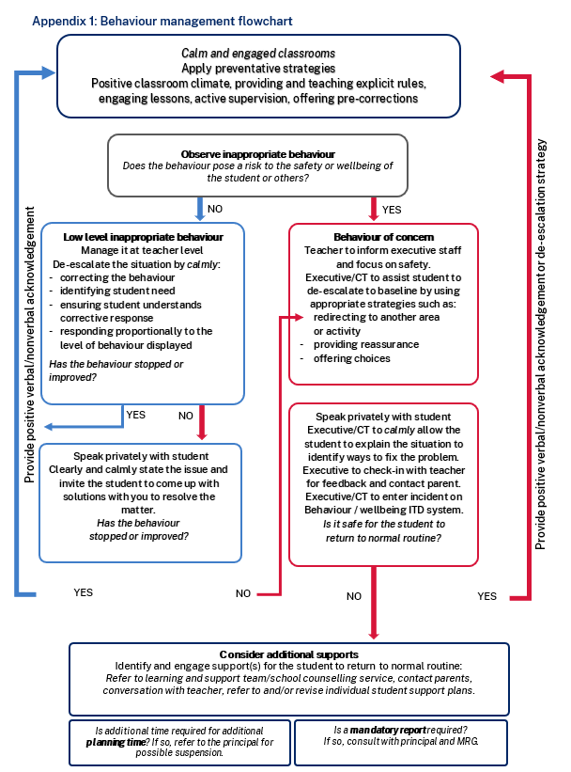

Bullying Response Flowchart
The following flowchart explains the actions Coopernook Public School staff will take when they receive a report about student bullying, including bullying which may have occurred online or outside of the school setting. The timeframes will vary depending on the professional judgment of staff who receive the bullying complaint and their assessment of immediate risk to student/s.

