
Mobile Phone User Agreement

Batlow Central School

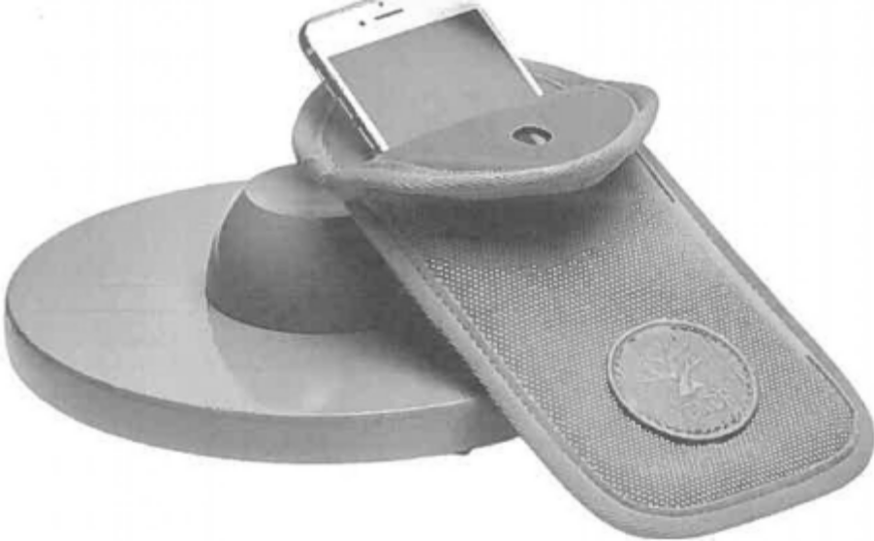

Yondr Phone Pouch Agreement

STUDENT NAME ___________________

YEAR __________

Student Agreement
Please tick each point to indicate your understanding.

I understand that if I bring personal electronic devices to school (including mobile phones, Smartwatches, laptops, iPads, etc), I do so at my own risk. I understand the school will NOT be responsible for the loss or damage of these
items.

I understand I am to keep my mobile phone in my allocated Yondr pouch while on school premises. I understand that failure to do so may result in disciplinary action being taken and/or my mobile phone being secured in the Office
and/or banned from coming to school.
I understand that taking photographs or videos while at school or engaged in school-related activities may only occur if there is a sound reason for the photography and my device has been unlocked from the Yondr pouch by a teacher
for a specific purpose.

I understand that it is my responsibility to bring my pouch with me to school every day.
I understand I must follow the process outlined below if I choose to bring a phone to school:
- Turn my mobile phone off.
- Unlock my empty Yondr Pouch using an unlocking base.
- Place my mobile phone inside the pouch, securely close it and store in my backpack.
- It will remain off and in the pouch inside my bag until I am leaving the school grounds, when I will open the pouch using an unlocking base and remove my phone. I will lock and store my pouch ready for use the next school day.
I understand that I will not do or cause the following:.
- Physically damage the pouch in an attempt to prevent its intended use, such as: bending the pin, stripping the lock, tearing or cutting the fabric.
- Over-ride the pouch security mechanism.
- Use my phone during school hours unless specifically instructed by a staff member.
- Use Bluetooth or Wi-Fi connectivity with my phone or voice activation, or use ear buds, a Smartwatch or any other device connected to a phone which is not turned off in the pouch.
- Decorate my pouch using offensive or inappropriate words or drawings.

I understand that losing or intentionally damaging my pouch will incur a $20 fee to replace the pouch.
Failure by me to follow the agreed mobile phone processes in the school will result in disciplinary action, including surrendering my phone to the front office and a parent meeting with the principal

Signature of Student: ___________________________ Signature of Parent: ___________________________

Signature of Year Adviser: ____________________
Signature of Principal: _______________________

Date ......../......../........

